Images of the User Interface (Frontend )

- Landing Page/Home Page of the Website




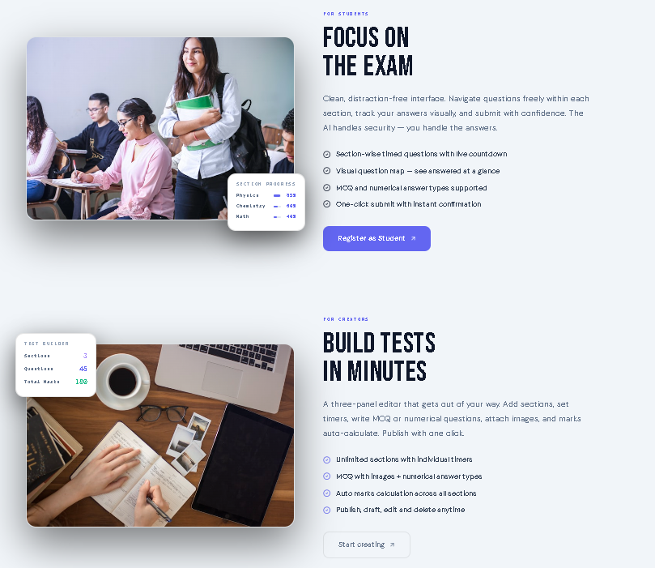
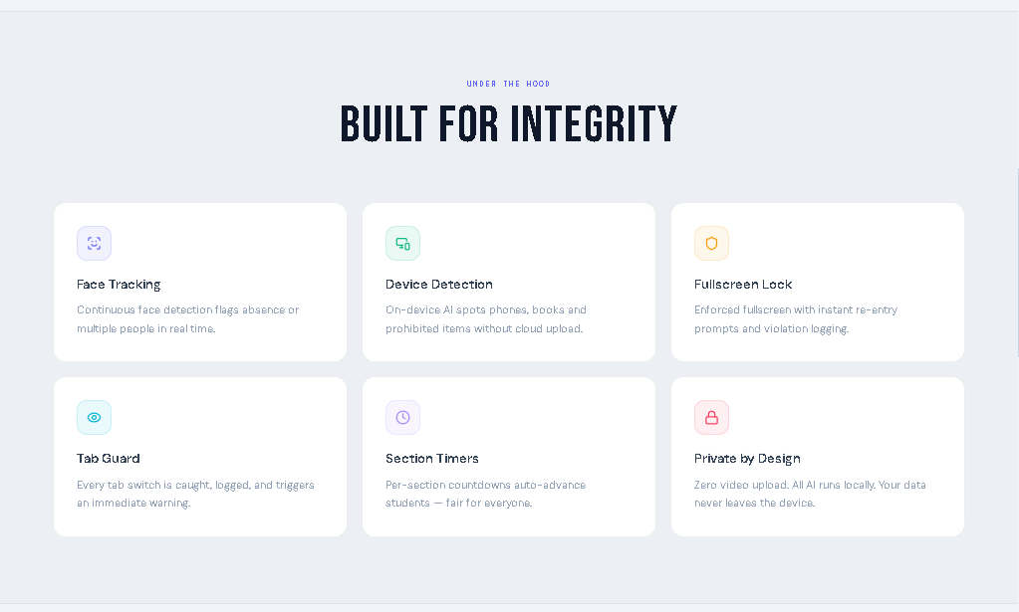

- About Page

It’s a basic about page of the website telling its story ,goal and mission.
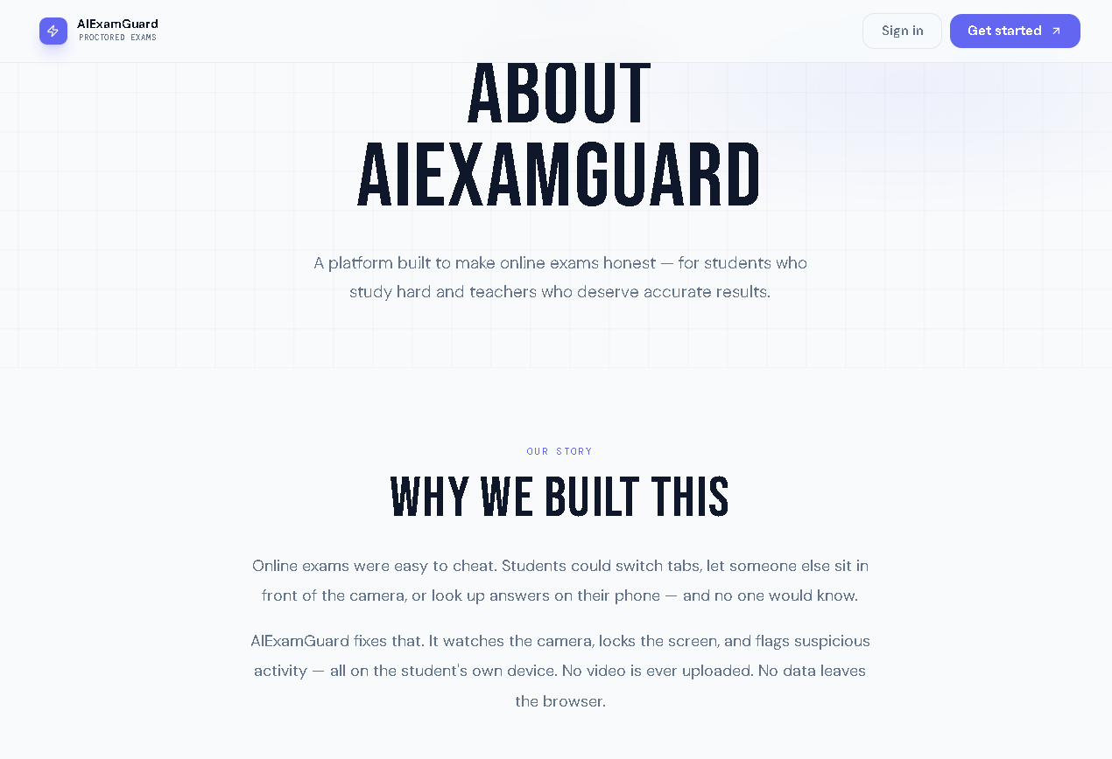
- Contact Us Page

It’s a basic contact page of me from which users can contact me through email .
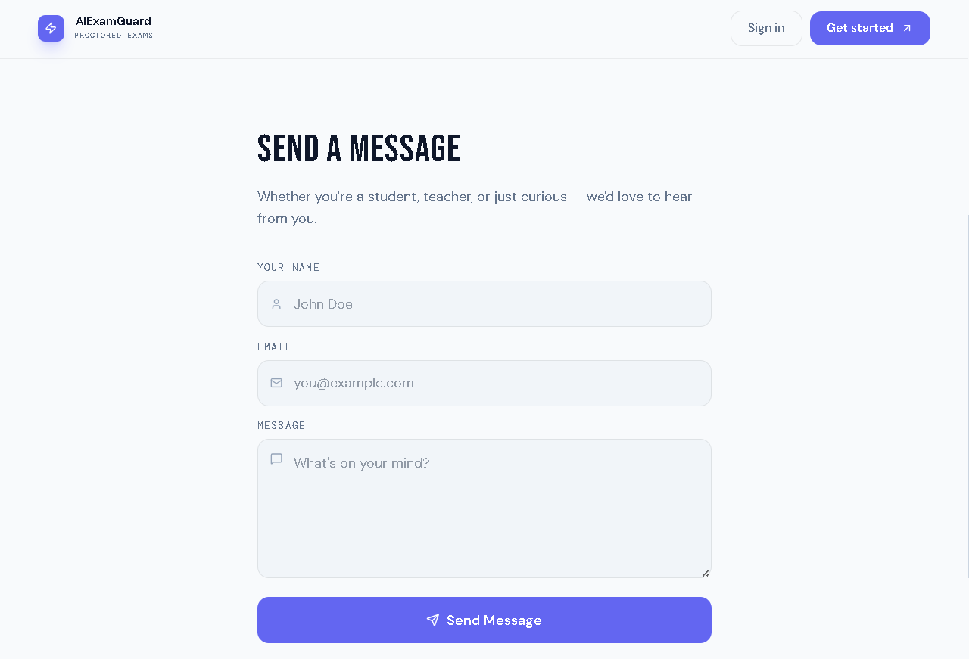

4.Login /Sign-Up - Every website needs to maintain info about their users for better user experience and to identify users to do which uneeds to sign up and then can log in to website

Login

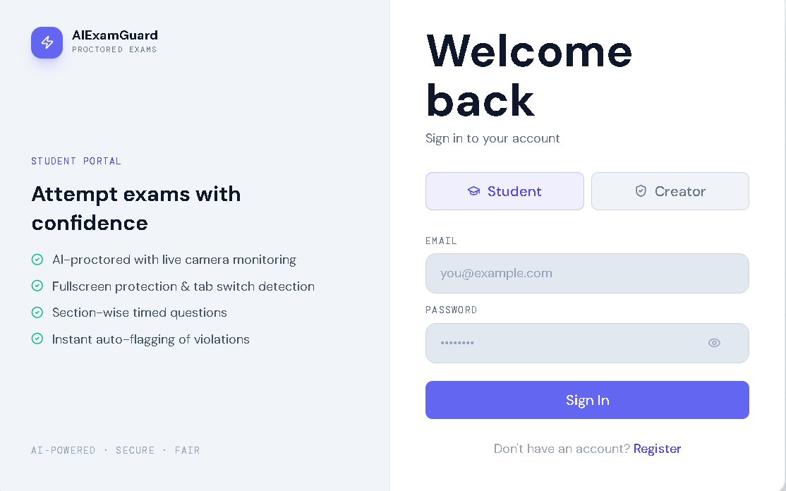

Sign Up

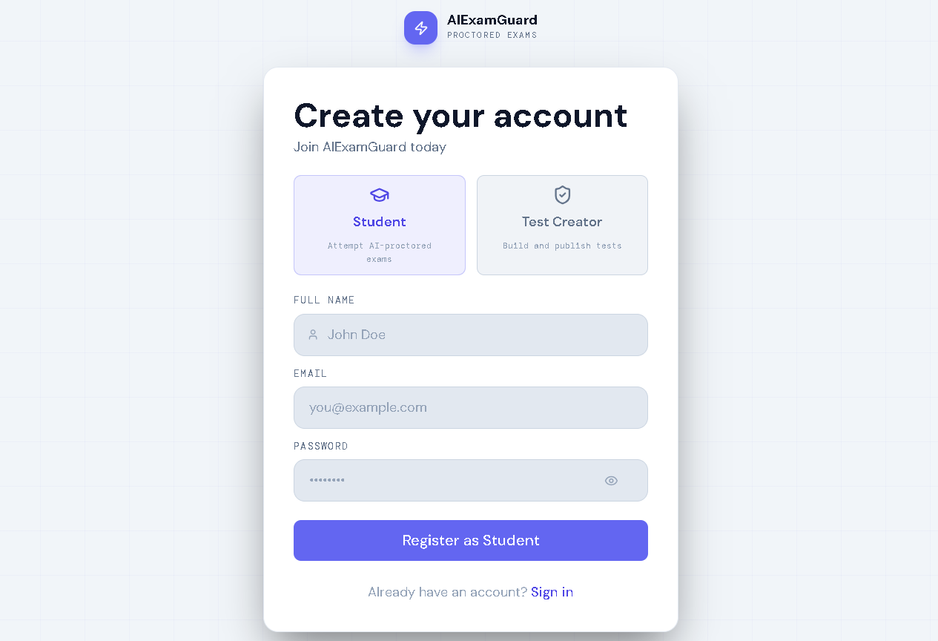

5.Dashboards - This is the main page from which a student can join test and creator can manage tests and students

Student Dashboard Page

In student dashboard student can join tests through test shared by creator and can start attempting the test by clicking start exam

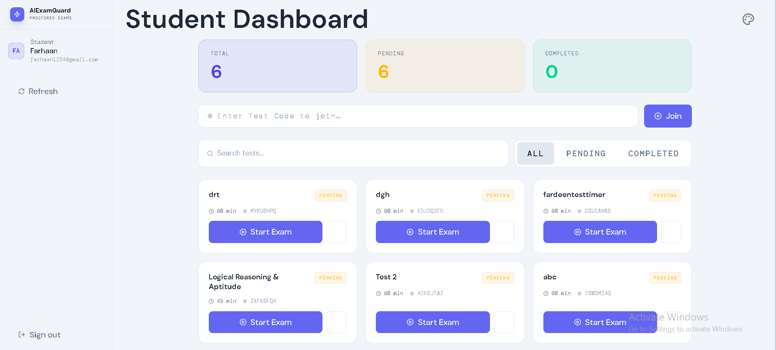

Creator Dashboard Page

In creator dashboard creator can create tests new test by clicking new Test button or can update existing test by clicking upon the test itself also creator can see who attempted test,their live monitoring and their result

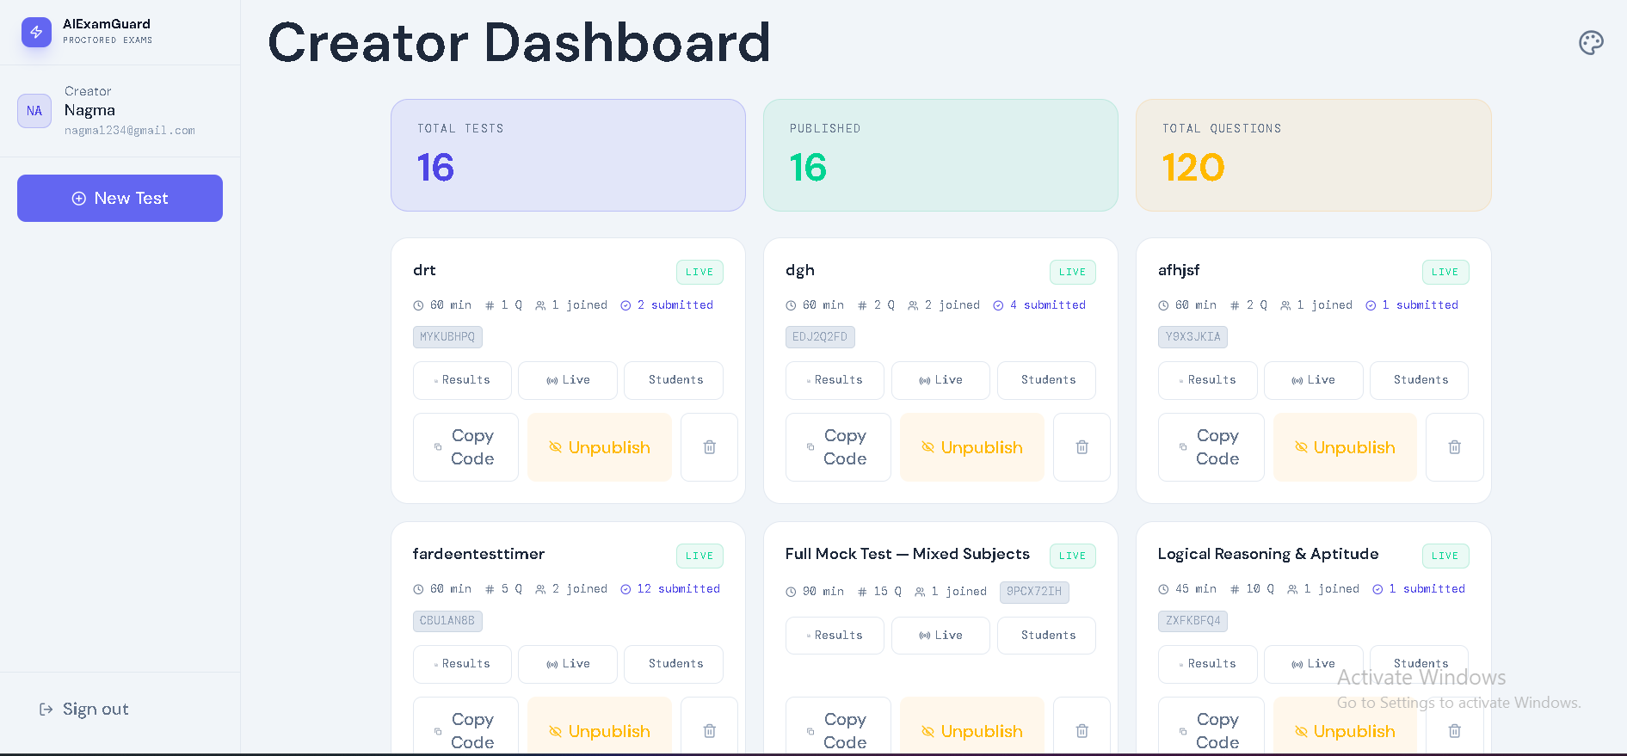

6.Test Creation Page - This page lets the user create tests and add infinite no of questions and sections , each question can be of two types mcq and numerical type creator could also add image in questions as well as in mcq options .

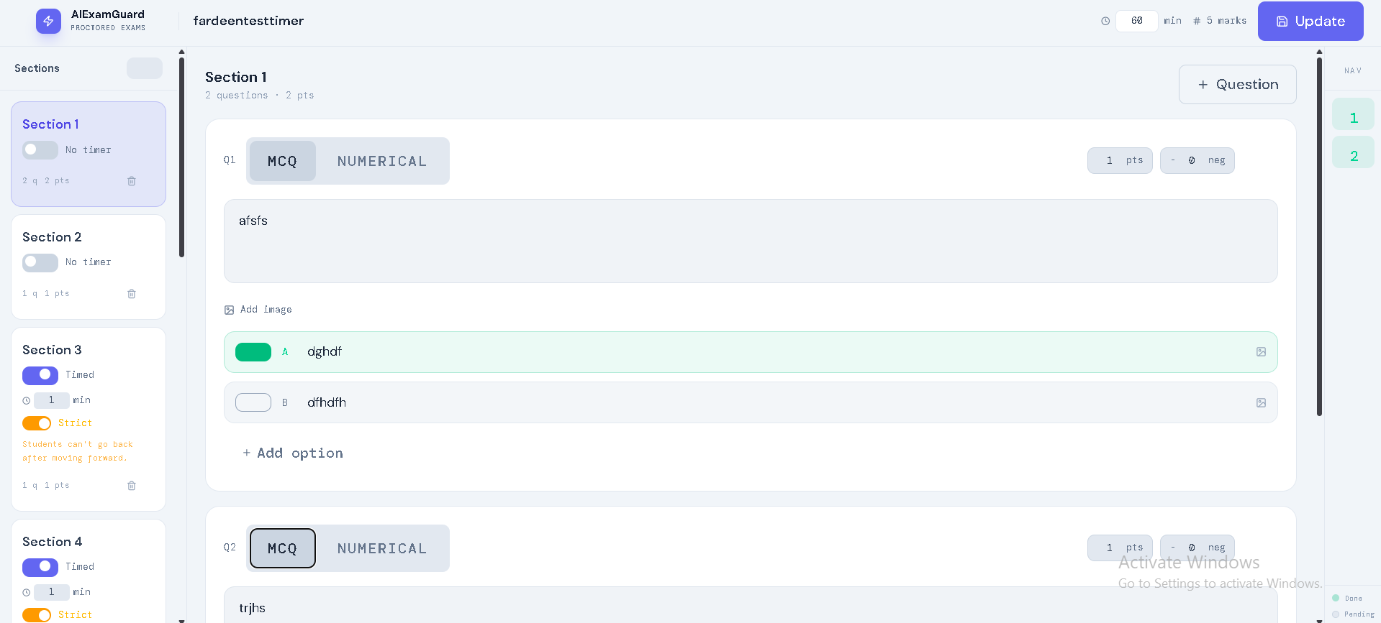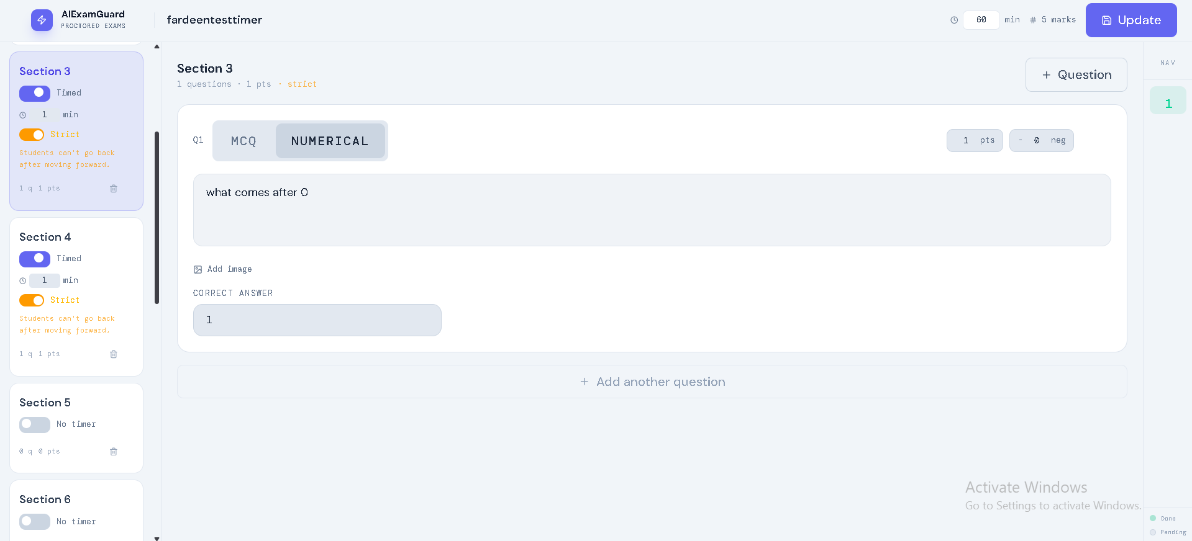

Creator can edit test title , creator can edit sections and can set timers for each sections as well creator could lock certain sections so that user cannot switch sections after coming to locked sections.

7.Exam Page - This page is the backbone of the entire system upon which student spends most of their time by attempting test generated by the creators .
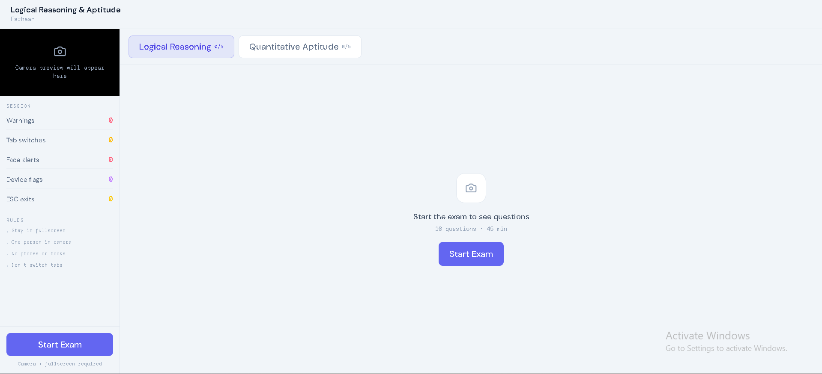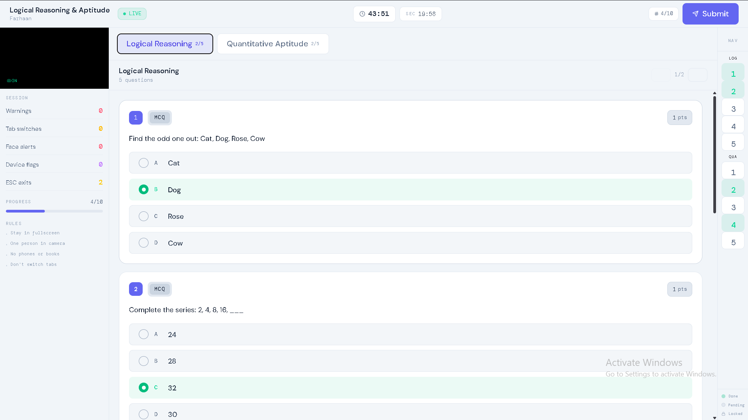

Result Pop-Up after Submitting the Test

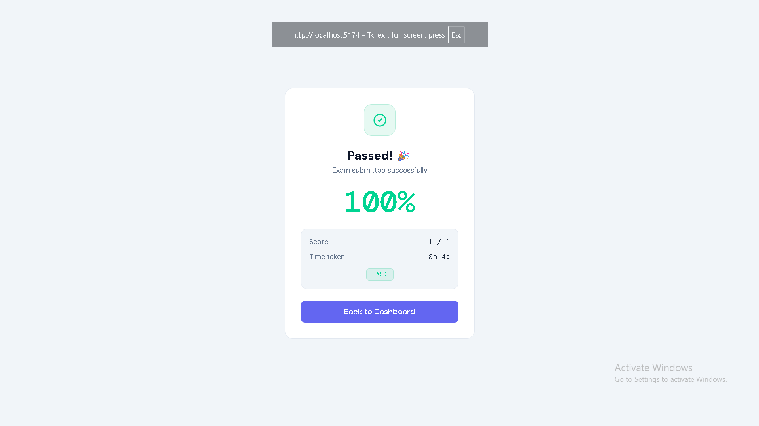

- Result and Attempts Page (Only For Creator to see)
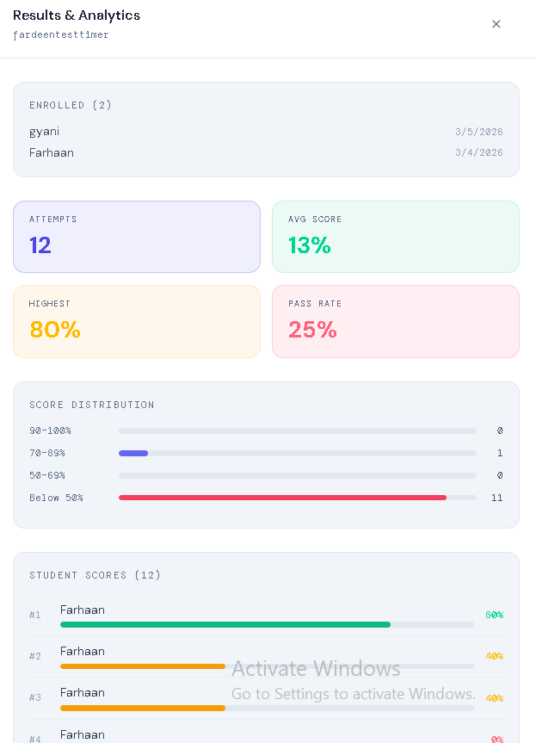
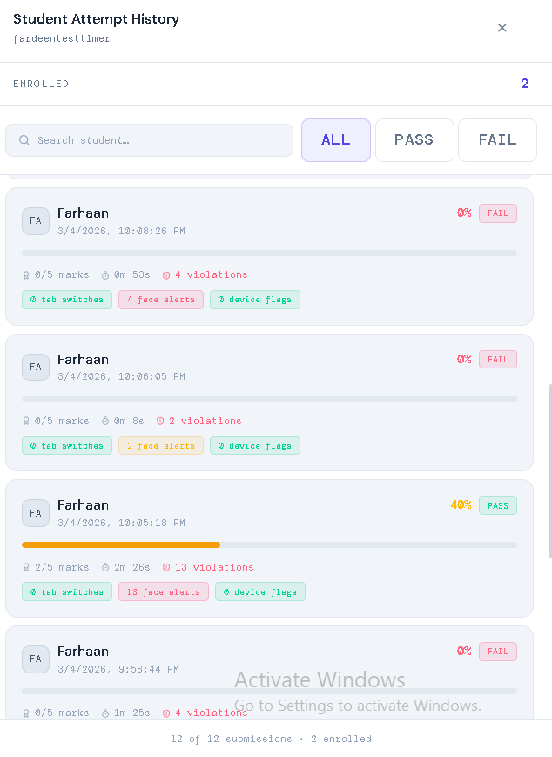

Code for Frontend

- Frontend Project Structure

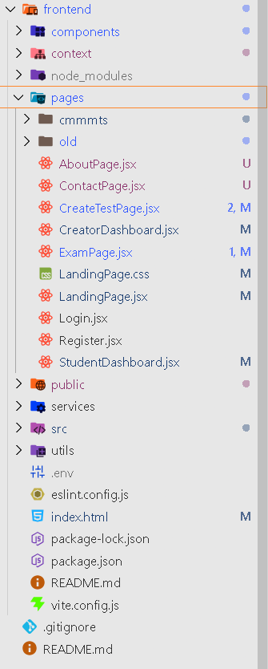

Main -- App.jsx

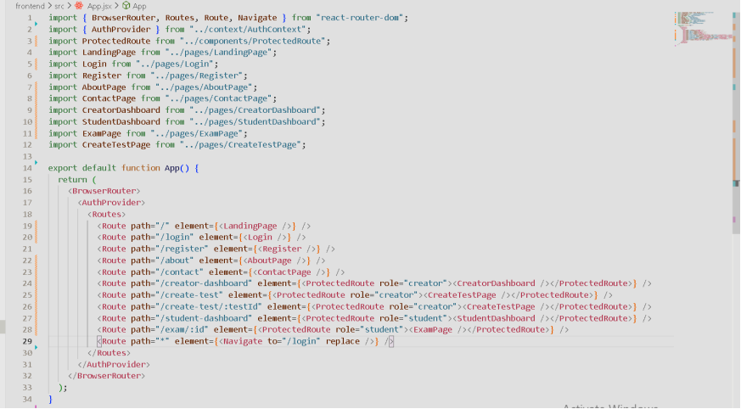
Main.jsx
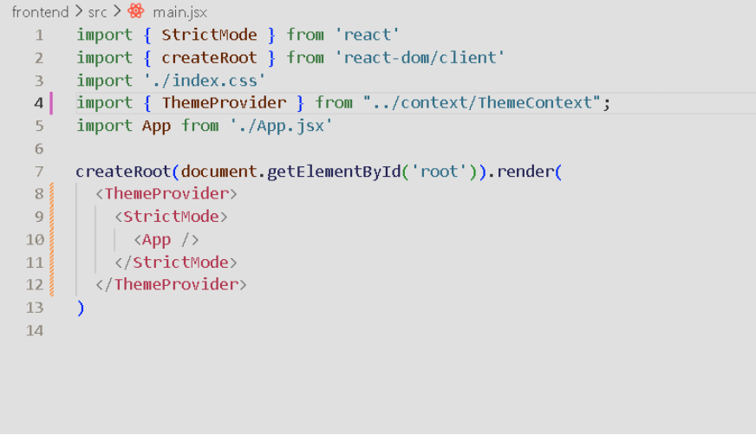

Complete Backend

- Project Structure of Backend
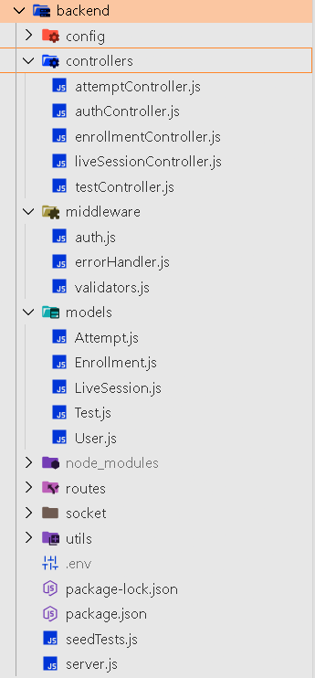

- Server.js - Entry point for all the request to backend

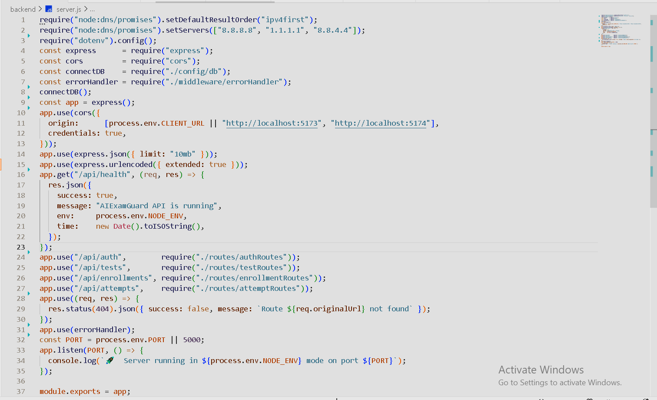

- MongoDB Database
